SMART PARKING SYSTEM

**A PROJECT REPORT**

***Submitted by***

***AAKIL SHIHAF V(210701004)***

***ASHIK MOHAMMED Y(210701035)***

***AAKASH A(210701002)***

***in partial fulfilment for the award of the degree of***

# BACHELOR OF ENGINEERING IN

**COMPUTER SCIENCE RAJALAKSHMI ENGINEERING COLLEGE**

# THANDALAM





**MAY 2024**

**BONAFIDE CERTIFICATE**

This is to certify that this project report titled **“SMART PARKING SYSTEM**” is the bonafide work of **“AAKIL SHIFAF V(210701004), ASHIK MOHAMMED Y(210701035), AAKASH A(210701002)”** who carried out the project work under my supervision.

## SIGNATURE

## MR. S.SURESH KUMAR,M.E.,

Professor

Department of Computer Science and Engineering Rajalakshmi Engineering College

Chennai - 602 105

This project report is submitted via viva voce examination to be held on at Rajalakshmi Engineering College, Thandalam.



# ACKNOWLEDGEMENT

First and foremost, I acknowledge the amazing Grace of God Almighty, who blessed my efforts and enabled me to complete this thesis in good health, mind, and spirit.

I am grateful to my Chairman **Mr.S.Meganathan**, Chairperson **Dr.Thangam Meganathan**, Vice Chairman **Mr.M.Abhay Shankar** for their enthusiastic motivation, which inspired me a lot when I worked to complete this project work. I also express our gratitude to our principal **Dr.S.N.Murugesan** who helped us in providing the required facilities in completing the project.

I would like to thank our Head of Department **Dr. P. KUMAR** for his guidance and encouragement for completion of project.

I would like to thank **MR. S. SURESH KUMAR,** our supervisor for constantly guiding us and motivating us throughout the course of the project. We express our gratitude to our parents and friends for extending their full support to us.

# ABSTRACT

The rapid urbanization and surge in vehicle numbers have exacerbated parking challenges, contributing to traffic congestion and pollution. To address these issues, an innovative IoT-based Smart Parking System has been developed, incorporating advanced yet cost-effective technologies. Central to this system are two strategically positioned infrared (IR) sensors designated as entry and exit sensors, which operate in conjunction with an Arduino board programmed to manage and monitor parking slot availability in real-time. The system's architecture includes the total number of parking slots pre-configured into the Arduino board. As a vehicle passes through the entry sensor, the system updates the slot count, decrementing it by one. Similarly, the exit sensor detects departing vehicles, prompting the system to increment the slot count, maintaining an accurate record of available spaces. This dynamic updating mechanism ensures efficient utilization of parking resources. A critical feature is the integration of a servo motor-operated barricade, linked with the slot availability logic. The barricade remains closed when the parking lot is full, preventing further entries and ensuring smooth traffic flow. The servo motor's precise control enables reliable operation of the barricade, enhancing user experience. The system offers robustness and scalability. The use of IR sensors provides reliable vehicle detection, while the Arduino's versatility allows for easy integration with additional components if needed. Despite the absence of payment gateways and camera modules, the system achieves high functionality and efficiency. It reduces the time drivers spend searching for parking, lowering fuel consumption and emissions, contributing to environmental sustainability.

# TABLE OF CONTENTS

|  |  |  |
| --- | --- | --- |
| **CHAPTER NO** | **TITLE** | **PAGE NO.** |
|  | **ACKNOWLEDGEMENT** | **iii** |
|  | **ABSTRACT** | **iv** |
|  | **LIST OF FIGURES** | **vii** |
|  | **LIST OF TABLES** | **viii** |
|  | **LIST OF SYMBOLS** | **ix** |
|  | **LIST OF ABBREVIATIONS** | **x** |
| **1** | **INTRODUCTION** | **1** |
| 1.1 | INTRODUCTION | 1 |
| 1.2 | PROBLEM STATEMENT | 2 |
| 1.3 | SOLUTION | 2 |
| 1.4 | SUMMARY | 3 |
| **2** | **LITERATURE SURVEY** | **4** |
| 2.1 | EXISTING SYSTEM | 5 |
| 2.2 | PROPOSED SYSTEM | 6 |
| **3** | **SYSTEM SPECIFICATION** | **7** |
| 3.1 | SYSTEM ARCHITECTURE | 7 |
| 3.2 | REQUIREMENT SPECIFICATION | 7 |
| 3.3 | COMPONENTS USED | 8 |
| 3.4 | WORKING PRINCIPLE | 9 |

|  |  |  |
| --- | --- | --- |
| **4** | **RESULT AND DISCUSSION** | **10** |
| 4.1 | ALGORITHM | 10 |
| 4.2 | IMPLEMENTATION | 11 |
| **5** | **OUTPUT** | **12** |
| 5.1 | OUTPUTS | 12 |
| 5.2 | SECURITY MODEL | 13 |
| **6** | **CONCLUSION AND FUTURE WORK** | **14** |
| 6.1 | CONCLUSION | 14 |
| 6.2 | FUTURE WORK | 15 |
|  | **REFERENCES** | **16** |
|  | **APPENDIX** | **17** |

**LIST OF FIGURES**

|  |  |  |
| --- | --- | --- |
| **FIGURE NO.** | **NAME OF FIGURES** | **PAGE NO.** |
| 3.1 | System Architecture | 7 |
| 5.1 | Output | 13 |

**LIST OF SYMBOLS**

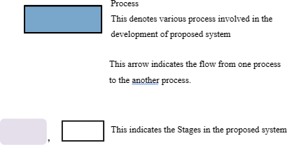

# ABBREVIATIONS

1. IoT - Internet of Things
2. SDK - Software Development Kit
3. IDE - Integrated Development Environment
4. Wi-Fi - Wireless Fidelity
5. LED - Light Emitting Diode
6. CAD - Computer-Aided Design
7. API - Application Programming Interface
8. USB - Universal Serial Bus
9. GPIO - General Purpose Input/Output
10. MCU - Microcontroller Unit
11. IR – Infra-Red

# CHAPTER 1 INTRODUCTION

* 1. **INTRODUCTION**

The advent of urbanization and the exponential growth of vehicle ownership have brought about significant challenges in urban planning, particularly in the management of parking spaces. Finding a parking spot in crowded city areas has become a common frustration for drivers, contributing to increased traffic congestion, higher fuel consumption, and elevated levels of pollution. To address these pressing issues, smart parking systems have emerged as a pivotal solution in the context of smart city initiatives.

This report presents the development and implementation of an IoT-based Smart Parking System designed to streamline parking management through real-time monitoring and efficient resource allocation. The system leverages infrared (IR) sensors and an Arduino microcontroller to detect vehicle entry and exit, dynamically adjusting the count of available parking slots. A servo motor-operated barricade ensures that the parking lot's capacity is never exceeded, enhancing the user experience and promoting orderly traffic flow within the parking area.

By integrating cost-effective technologies, this Smart Parking System not only optimizes parking space utilization but also contributes to environmental sustainability by reducing the time spent searching for parking and lowering associated emissions. This report details the system's architecture, components, and operational workflow, demonstrating its potential as a practical and scalable solution for modern urban parking challenges.

## PROBLEM STATEMENT:

Urban areas worldwide are grappling with severe parking challenges due to the increasing number of vehicles and limited parking infrastructure. This situation leads to significant issues, including prolonged search times for parking spaces, traffic congestion, increased fuel consumption, and elevated emissions. Drivers often experience frustration and inefficiency as they circle streets or parking lots in search of available spaces. This not only contributes to environmental pollution but also affects the overall quality of urban life. Existing parking solutions are often inadequate, lacking real-time data and efficient management capabilities. Hence, there is a pressing need for an innovative, reliable, and cost-effective smart parking system that can optimize the use of available parking spaces, reduce congestion, and enhance the urban driving experience.

## SOLUTION:

To address the pressing parking challenges in urban areas, we propose an IoT-based Smart Parking System that leverages modern sensor technology and automation to provide a practical and efficient solution. This system employs infrared (IR) sensors to monitor vehicle entry and exit in real-time, connected to an Arduino microcontroller that dynamically updates the count of available parking slots. By pre-configuring the total number of parking slots into the Arduino, the system accurately tracks and manages space utilization.

A crucial component of the solution is a servo motor-operated barricade that controls access to the parking area. When the parking lot reaches full capacity, the barricade remains closed, preventing further entries and thus avoiding unnecessary congestion and frustration for drivers. This automated control ensures orderly traffic flow and maximizes the efficient use of parking resources.

The Smart Parking System is designed to be cost-effective, scalable, and easy to implement, making it suitable for various urban settings. It significantly reduces the time drivers spend searching for parking, which in turn lowers fuel consumption and emissions, contributing to environmental sustainability. Additionally, the system's real-time monitoring capabilities provide valuable data that can inform urban planning and traffic management strategies. Overall, this solution not only enhances the user experience but also promotes a more efficient and eco-friendly urban environment.

* 1. **SUMMARY:**

This report introduces an innovative IoT-based Smart Parking System specifically designed to address the pressing challenges associated with urban parking. The system integrates advanced infrared sensors and an Arduino microcontroller to dynamically monitor and provide real-time updates on the availability of parking slots. To effectively manage access, a servo motor-operated barricade is utilized, which automatically prevents entry when the parking lot reaches full capacity. This not only alleviates congestion but also reduces frustration among drivers searching for parking spaces. The Smart Parking System is characterized by its cost-effectiveness, scalability, and environmentally friendly nature. It significantly reduces the time spent searching for parking, thereby cutting down on fuel consumption and emissions. By optimizing the utilization of parking spaces and offering valuable real-time data, this system presents a practical and efficient solution for improving urban mobility. Additionally, it supports sustainable urban development by contributing to the reduction of traffic-related pollution and enhancing the overall efficiency of urban transportation infrastructure. Beyond its immediate benefits, the IoT-based Smart Parking System also offers a platform for future technological enhancements and integrations. For instance, the real-time data collected can be leveraged for advanced analytics, helping city planners make informed decisions about urban infrastructure improvements.

# CHAPTER 2 LITERATURE SURVEY

1. **Paper:** Smart Parking System Using IoT
   * **Author**: Denis Ashok, Akshat Tiwari, Vipul Jirge
   * **Year:** 2020
   * **Disadvantage:** Higher complexity architecture. Comparatively more costlier because of its complexity.
2. **Paper:** Smart Car Parking Management System
   * **Author:** Lomat Haider Chowdhury, Z.N.M Zarif Mahmud, Intishar-Ul Islam, Ishrat Jahan and Salekul Islam
   * **Year:** 2019
   * **Disadvantage:** Usage of RFID is unnecessary based on the scale of the project and induces additional layer of complexity.
3. **Paper:** IoT based Smart Parking System
   * **Author:** Abhirup Khanna, Rishi Anand
   * **Year:** 2016
   * **Disadvantage:** Makes use of online cloud databases for data storage, which might prove to increase expenditure.
4. **Paper:** Smart Parking System using Image Processing Techniques in Wireless Sensor Network Environment
   * **Author:** Mohd Yamani Idna Idris, Zaidi Razak
   * **Year:** 2009
   * **Disadvantage:** Uses a Kiosk system for ticket distribution which is time consuming and increase expenditure.
5. **Paper:** Smart Parking Management System
   * **Author:** Prasad Narode, Samruddhi Kalekar, Sanket Sanap
   * **Year:** 2020
   * **Disadvantage:** Requires dedicated server which costs more

**2.1 EXISTING SYSTEM:**

Traditional parking management systems are often plagued by inefficiencies and driver frustrations due to their reliance on manual processes and outdated physical infrastructure. In these conventional systems, determining parking availability typically involves manual inspection or the use of simple indicators such as signs displaying "full" or "available." This approach fails to provide real-time data, leading to drivers spending excessive amounts of time searching for parking spaces. This inefficiency not only inconveniences drivers but also contributes significantly to traffic congestion and increased environmental pollution due to prolonged idling and driving in circles.

Furthermore, these systems generally lack automated mechanisms for controlling access to parking areas. In the absence of automated access control, drivers may attempt to enter already full parking lots, exacerbating congestion and leading to heightened frustration. The lack of dynamic entry regulation means that once a lot is full, there is no system in place to prevent additional vehicles from attempting to enter, causing bottlenecks and further complicating the parking process.

Traditional systems are often rigid, making it difficult to integrate new technologies or adapt to evolving urban landscapes. This inflexibility can hinder a city's ability to efficiently manage its parking resources, ultimately affecting overall urban mobility and quality of life.

The limitations of these existing systems highlight the urgent need for innovative solutions that leverage modern technologies. Such solutions can improve efficiency, optimize space utilization, and significantly enhance the overall urban driving experience. By addressing these challenges with advanced technologies, cities can reduce traffic congestion, lower environmental impacts, and create a more streamlined and user-friendly parking experience for drivers.

**2.2 PROPOSED SYSTEM:**

The proposed Smart Parking System represents a paradigm shift in parking management, leveraging IoT technology to address the shortcomings.

At the heart of the proposed system are infrared (IR) sensors strategically positioned at entry and exit points of the parking area. These sensors continuously monitor vehicle movement, accurately detecting entry and exit events in real-time. The data collected by the sensors are transmitted to an Arduino microcontroller, which serves as the central processing unit of the system.

The Arduino microcontroller is programmed to dynamically update the count of available parking slots based on the sensor inputs. By pre-configuring the total number of parking slots into the system, the microcontroller ensures accurate and efficient management of parking space utilization.

A crucial feature of the proposed system is the integration of a servo motor-operated barricade at the entrance of the parking area. When the number of available parking slots reaches zero, the microcontroller signals the servo motor to close the barricade, preventing further entries into the parking lot. This automated access control mechanism helps alleviate congestion and ensures a smooth traffic flow within the parking area.

Furthermore, the proposed system is designed to be scalable and adaptable to different urban environments. Additional sensors can be easily integrated to monitor parking availability in larger parking facilities, while the Arduino platform allows for seamless expansion and customization of the system according to specific requirements.

Overall, the proposed Smart Parking System offers a cost-effective, efficient, and environmentally friendly solution to urban parking management

# CHAPTER 3 SYSTEM ARCHITECTURE

* 1. **SYSTEM ARCHITECTURE**

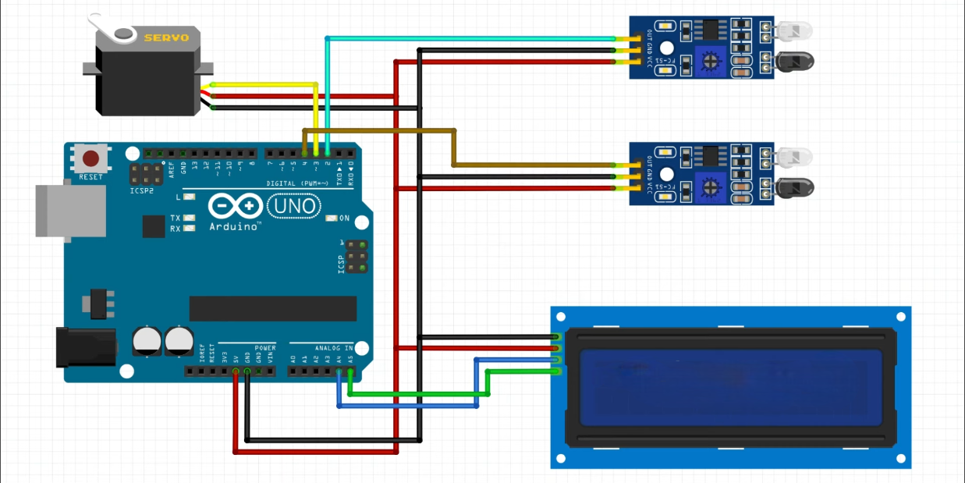

Fig 3.1 System Architecture

* 1. **REQUIREMENT SPECIFICATION:** 
     1. **HARDWARE SPECIFICATION**

Arduino Uno Board

Servo Motor

IR Sensors(2 Nos.)

Breadboard

* + 1. **SOFTWARE SPECIFICATION**

Arduino IDE

C++ (14)

* 1. **COMPONENTS USED**

• **Arduino Uno Board**:

The Arduino Uno is a widely used microcontroller board based on the ATmega328P chip. It offers digital and analog input/output pins, facilitating interfacing with various sensors, actuators, and electronic components. In our Smart Parking System, the Arduino Uno serves as the central control unit, executing programmed instructions to manage parking slot availability and control the servo motor-operated barricade.

• **Infrared (IR) Sensors:**

Infrared sensors are utilized to detect vehicle entry and exit in real-time within the parking area. These sensors emit and detect infrared radiation, allowing for accurate detection of vehicles passing through designated entry and exit points. The IR sensors provide essential data inputs to the Arduino Uno for dynamically updating the count of available parking slots.

**• Servo Motor**:

A servo motor is employed to operate the barricade mechanism, regulating access to the parking area based on the availability of parking slots. The servo motor's precise control enables the barricade to open and close smoothly, ensuring orderly traffic flow within the parking facility.

**• Jumper Cables:**

Jumper cables are essential for establishing electrical connections between components on a breadboard or between components and the Arduino Uno. These cables typically feature insulated wires with male or female connectors on each end, facilitating versatile and secure connections in the circuit.

# WORKING PRINCIPLE

The The Smart Parking System is a sophisticated solution designed to address urban parking challenges by leveraging a combination of hardware and software components. At its core are infrared sensors strategically positioned at the entry and exit points of the parking area. These sensors continuously monitor vehicle movement, detecting when a vehicle enters or exits the parking facility.

Upon detection of a vehicle, the sensors transmit signals to the central control unit, which comprises an Arduino microcontroller. The microcontroller processes the incoming data in real-time, dynamically updating the count of available parking slots based on the entry and exit events. This allows the system to maintain an accurate and up-to-date record of parking space availability at any given time.

The core system lies in the servo motor-operated barricade situated at the entrance of the parking area. When the available parking slots reach capacity, the Arduino microcontroller commands the servo motor to close the barricade, preventing additional vehicles from entering. Conversely, as parking slots become available due to vehicles exiting, the microcontroller signals the servo motor to open the barricade, enabling incoming vehicles to access the parking facility.

This seamless interaction between the sensors, microcontroller, and servo motor ensures efficient management of parking space utilization, minimizing congestion and optimizing traffic flow within the parking facility. By providing real-time updates on parking availability and dynamically controlling access to the parking area, the Smart Parking System enhances the overall parking experience for drivers while contributing to a more organized and efficient urban environment.

# CHAPTER 4 RESULT AND DISCUSSION

* 1. **ALGORITHMDescription**

The algorithm implemented in the Smart Parking System governs the real-time monitoring of parking slot availability and the control of the servo motor-operated barricade. It involves initializing the system, continuously monitoring parking slot status, controlling the barricade based on availability, handling errors, and ensuring continuous operation. The system initializes by setting up all components and initializing variables such as total parking slots and available parking slots.

Parking slot monitoring involves constantly checking input from infrared sensors at entry and exit points. When a vehicle enters, the available slot count decreases, and when a vehicle exits, it increases. Real-time data is updated accordingly.

Barricade control checks the available parking slot count after each entry or exit. If no slots are available, the servo motor closes the barricade to prevent further entries. When slots become available, the barricade opens. Error handling mechanisms address any malfunctions or irregularities in sensor readings or system operation. Alerts or notifications may be triggered to indicate system failures, facilitating timely troubleshooting.

Continuous operation ensures uninterrupted monitoring and control of parking slot availability and barricade status. System reset or initialization mechanisms maintain stability and reliability in case of disruptions like power outages.

Efficient execution of this algorithm optimizes parking resource utilization, minimizes congestion, and enhances the overall urban parking experience.

# 4.2 IMPLEMENTATION:

The implementation of the Smart Parking System involves assembling and configuring the necessary hardware components, writing and uploading the Arduino code, and conducting testing and validation to ensure proper functionality. Firstly, the hardware components including the Arduino Uno board, infrared (IR) sensors, servo motor, jumper cables, breadboard, power supply unit, and enclosure are assembled according to the system design requirements. The IR sensors are positioned at the entry and exit points of the parking area, and the servo motor is installed to control the barricade mechanism.

Next, the Arduino code is written to implement the algorithm described earlier. This code includes initializing the system, monitoring parking slot availability, controlling the barricade based on slot availability, handling errors, and ensuring continuous operation. The code is uploaded to the Arduino Uno board using the Arduino IDE or a similar programming environment.

Once the hardware and software components are assembled and configured, testing and validation procedures are conducted to verify the system's functionality and performance. This includes testing the accuracy of the IR sensors in detecting vehicle entry and exit, verifying the proper operation of the servo motor in controlling the barricade, and ensuring the overall reliability of the system under various conditions.

During testing, adjustments may be made to the hardware configuration or software code to address any issues or optimize system performance. Once the system has been thoroughly tested and validated, it is ready for deployment in real-world urban parking environments.

# OUTPUT:

# C:\Users\ACER NEW\AppData\Local\Packages\5319275A.WhatsAppDesktop_cv1g1gvanyjgm\TempState\6177A45CB50F7D46DE52A4AEE0C17629\WhatsApp Image 2024-05-15 at 13.13.56_4cd69e85.jpg

Fig 5.2.1 Overall Picture of the System

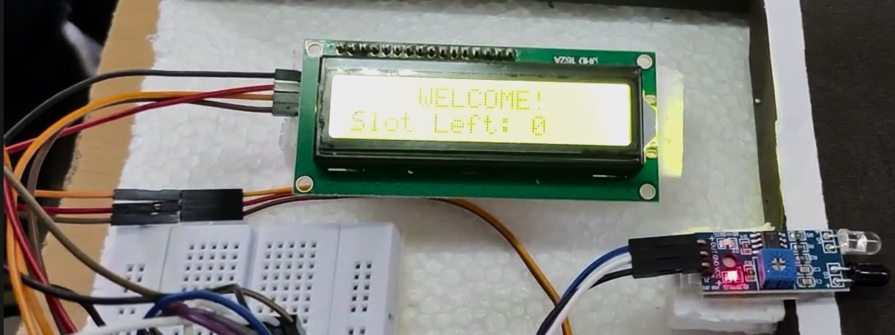

Fig 5.2.2 Available Slot Indication

# C:\Users\ACER NEW\AppData\Local\Packages\Microsoft.Windows.Photos_8wekyb3d8bbwe\TempState\ShareServiceTempFolder\Screenshot (41).jpeg

Fig 5.2.3 Slots Filled Indication

# SECURITY MODEL:

Arduino's security model revolves around several key practices to ensure the integrity and reliability of its projects.

Firstly, code security is paramount. Developers must craft code that is free from vulnerabilities such as buffer overflows or injection attacks, and validate input data to prevent exploitation. Additionally, access control measures are vital. Limiting physical access to the Arduino board and connected components helps prevent unauthorized tampering.

Secure communication protocols like HTTPS or MQTT, with authentication and encryption, are essential for protecting data integrity and confidentiality. Regular firmware updates are crucial to patch security vulnerabilities and enhance system reliability, ensuring that the Arduino board remains protected.

Implementing authentication mechanisms, such as password or token-based authentication, verifies the identity of users or devices interacting with the system. Encrypting sensitive data stored or transmitted by the Arduino board adds an extra layer of security against unauthorized access. Monitoring system activities and logging them helps detect security incidents or anomalies, enabling timely responses to threats.

Finally, physical security measures like security cameras or alarm systems safeguard the Arduino board from theft, tampering, or unauthorized access in its deployment environment. Together, these practices form the basis of Arduino's security model, ensuring that its projects are robust and resilient against potential threats.

# CHAPTER 6

**CONCLUSION AND FUTURE WORK**

# CONCLUSION

In conclusion, the Smart Parking System represents a significant advancement in urban parking management, leveraging IoT technology to address the challenges of parking space availability and congestion in crowded city environments. By implementing an innovative combination of infrared sensors, Arduino microcontroller, servo motor-operated barricade, and real-time monitoring capabilities, the Smart Parking System offers a practical and efficient solution for optimizing parking space utilization and enhancing the urban driving experience.

The successful implementation of the Smart Parking System demonstrates the potential of IoT technology to revolutionize urban infrastructure and improve the quality of life for city residents. By reducing search times for parking, minimizing congestion, and lowering fuel consumption and emissions, the system contributes to a more sustainable and efficient urban environment. Moreover, the system's scalability and cost-effectiveness ensure that it can be adapted to various urban settings, making it a versatile solution for cities worldwide.

Overall, the Smart Parking System exemplifies the transformative power of IoT technology in addressing complex urban challenges and shaping the cities of the future. Through continued innovation and collaboration, IoT-based solutions like the Smart Parking System have the potential to create smarter, more sustainable, and more livable cities for generations to come. As urban populations continue to grow, such advanced systems will be integral in maintaining the functionality and livability of our urban environments.

# FUTURE WORK

In considering future works for the Smart Parking System, several avenues for improvement and expansion emerge.

Enhancing the system's scalability to accommodate larger parking facilities and more complex urban environments is crucial. This may involve optimizing hardware and software components to handle a greater volume of data and interactions, and integrating additional sensors or technologies to improve accuracy and reliability.

Moreover, integrating advanced analytics and machine learning algorithms into the Smart Parking System can unlock valuable insights for urban planners and policymakers. By analyzing real-time parking data, such as usage patterns and demand forecasting, decision-makers can optimize parking infrastructure, reduce congestion, and enhance overall urban mobility.

Additionally, exploring the integration of smart payment systems and digital signage can further streamline the parking experience for users. Implementing cashless payment options, mobile apps for reservations, and dynamic signage displaying real-time parking availability can improve user convenience and satisfaction while providing revenue opportunities for parking operators.

By addressing these areas of future work, the Smart Parking System can continue to evolve and adapt to the changing needs and challenges of urban environments, ultimately contributing to the creation of smarter, more sustainable cities.

# REFERENCES

* + 1. "Building the Internet of Things: Implement New Business Models, Disrupt Competitors, Transform Your Industry" by Maciej Kranz
    2. "Designing Connected Products: UX for the Consumer Internet of Things" by Claire Rowland, Elizabeth Goodman, Martin Charlier, and Ann Light
    3. "The Internet of Things (The MIT Press Essential Knowledge series)" by Samuel Greengard
    4. "Building Arduino Projects for the Internet of Things: Experiments with Real-World Applications" by Adeel Javed
    5. "Internet of Things (A Hands-on-Approach)" by Arshdeep Bahga and Vijay Madisetti
    6. "Practical Internet of Things Security" by Brian Russell, Drew Van Duren, and John Kemp
    7. "Internet of Things: A Hands-On Approach" by Miguel Ángel González-López, Francisco Javier Rodríguez Lera, and Raquel Lacuesta Gilaberte
    8. "The Silent Intelligence: The Internet of Things" by Daniel Kellmereit and Daniel Obodovski

# APPENDIX

#include <Wire.h>

#include <LiquidCrystal\_I2C.h>

LiquidCrystal\_I2C lcd(0x3F,16,2); //Change the HEX address

#include <Servo.h>

Servo myservo1;

int IR1 = 2;

int IR2 = 4;

int Slot = 4; //Enter Total number of parking Slots

int flag1 = 0;

int flag2 = 0;

void setup() {

lcd.begin();

lcd.backlight();

pinMode(IR1, INPUT);

pinMode(IR2, INPUT);

myservo1.attach(3);

myservo1.write(100);

lcd.setCursor (0,0);

lcd.print(" ARDUINO ");

lcd.setCursor (0,1);

lcd.print(" PARKING SYSTEM ");

delay (2000);

lcd.clear();

}

void loop(){

if(digitalRead (IR1) == LOW && flag1==0){

if(Slot>0){flag1=1;

if(flag2==0){myservo1.write(0); Slot = Slot-1;}

}else{

lcd.setCursor (0,0);

lcd.print(" SORRY :( ");

lcd.setCursor (0,1);

lcd.print(" Parking Full ");

delay (3000);

lcd.clear();

}

}

if(digitalRead (IR2) == LOW && flag2==0){flag2=1;

if(flag1==0){myservo1.write(0); Slot = Slot+1;}

}

if(flag1==1 && flag2==1){

delay (1000);

myservo1.write(100);

flag1=0, flag2=0;

}

lcd.setCursor (0,0);

lcd.print(" WELCOME! ");

lcd.setCursor (0,1);

lcd.print("Slot Left: ");

lcd.print(Slot);

}